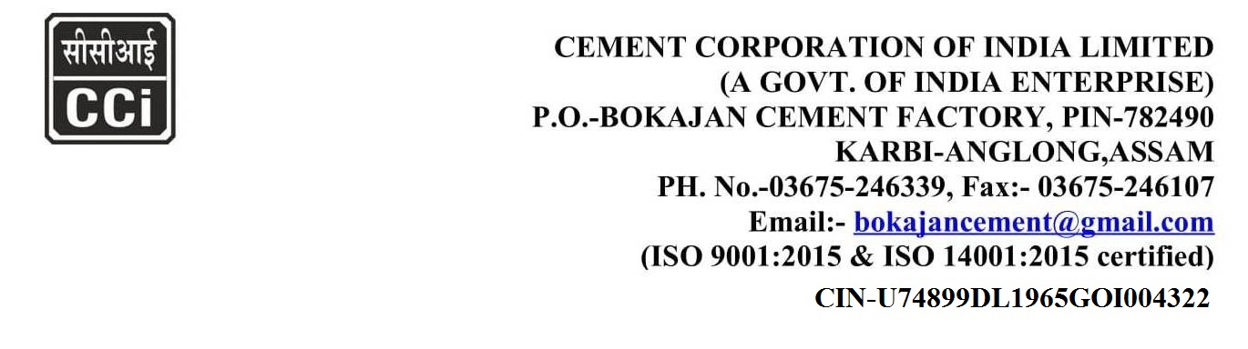
CORRIGENDUM-I
Subject: - Procurement of Belt weigh Feeder for Cement Mill at Bokajan Cement Factory of CCI.

Tender No. BKJ/MM/M-5690/23-24
Date: 22.03.2024

With reference to our Tender No. BKJ/MM/M-5690 /23-24, dtd. 22.03.2024 which is published on CPP portal for Procurement of Belt weigh Feeder for Cement Mill at Bokajan Cement Factory of CCI. The due date for submission of tender was 22.03.2024 which is extended till 29.03.2024.

HOD(MM)
Cement Corporation of India Ltd.,
Bokajan Cement Factory – 782 490,
Dist. Karbi Anglong, Assam.
Website: www.cciltd.in

